How to query and quad collections for list 3 and 4 plants

This procedure will allow you to take a batch of collection records with coordinates and use ArcGIS to determine which quads the collections came from.

Go to the Consortium of California Herbaria webpage: http://ucjeps.berkeley.edu/consortium/

Enter the scientific name in the upper left field and hit Enter.

When the results appear, click on the “Collection Date” heading to sort the results in ascending date order. Then click “Select all records” and click “Retrieve selected records as tab-separated list” The places to click are circled in red below:

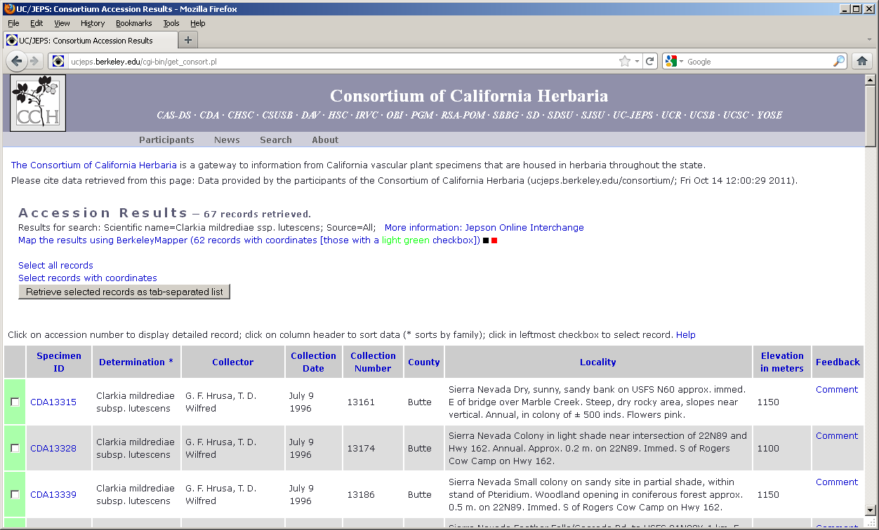

A page will appear which looks like nonsense. Go to File → Save As…
and then save this nonsense webpage as a text file.

Open Excel. Go to Data → Import External Data → Import Data…
Navigate to where you saved the text file and open it. Sometimes our version of Excel 2002 will not display text files unless you change the “Files of type” to “All Files”. This appears to be a bug.

The Text Import Wizard will open. Just hit Finish and then hit OK when the Import Data dialog appears.

You should now have an Excel workbook of collection records. Save and close it.

Open an ArcMap project which contains a quad boundaries layer. The CNDDB project will suffice. Go to Tools → Add XY Data…

The Add XY Data dialog will appear. The top field will ask you to choose a table. Navigate to your Excel file, select the worksheet within the Excel file that contains your data, and hit Add. (Note: If you didn’t change any settings the worksheet with your data is probably named “Sheet1$get_consort_pl)

Make sure you have longitude specified for the X Field and latitude specified for the Y field. You will probably have to change the setting for the Y Field. Now click Edit.

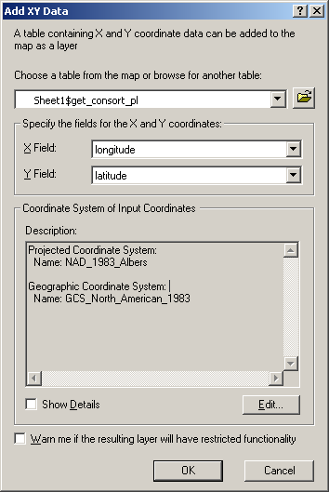

When the next dialog appears, click Select…
You need to specify the coordinate system of lat/long, NAD83. To do this you will need to open the folder named Geographic Coordinate Systems, then open North America, then select North American Datum 1983.prj
Click Add, then click OK, then click OK again.

A new point events layer should now appear in your ArcMap project. This events layer will need to be converted into a shapefile for further analysis. Right-click the layer, select Data, then select Export Data…
Specify where you would like to save the shapefile and click OK. When asked if you would like to add the exported data to the map, click Yes.

Now go to ArcToolbox, open Analysis Tools, open Overlay, and double-click on Identity.

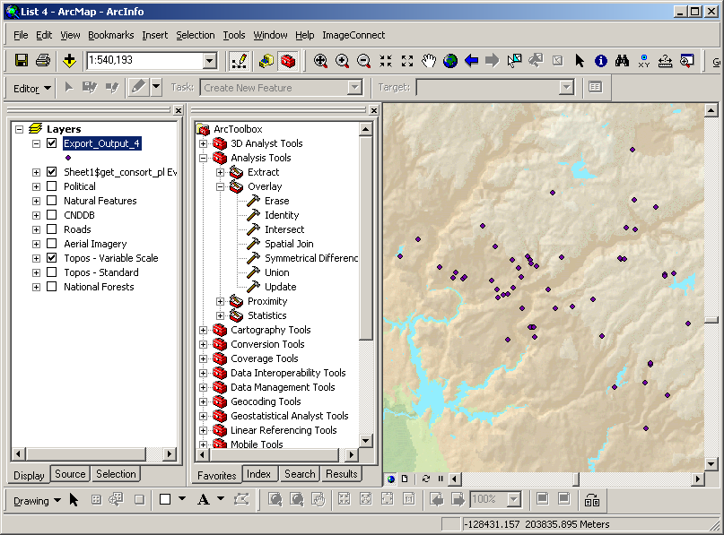

The Identity Tool dialog will now appear. Left-click, grab, and drag your point shapefile over to Input Features field. (You must use the layer you exported as a shapefile, not the original events layer you created.) Grab and drag the Quad Boundaries layer (which is probably stored inside the Political group layer) over to the Identity Features field. Use the Output Feature Class field to specify where you would like to store a new shapefile which will contain your collection records with quad information added. Click OK.

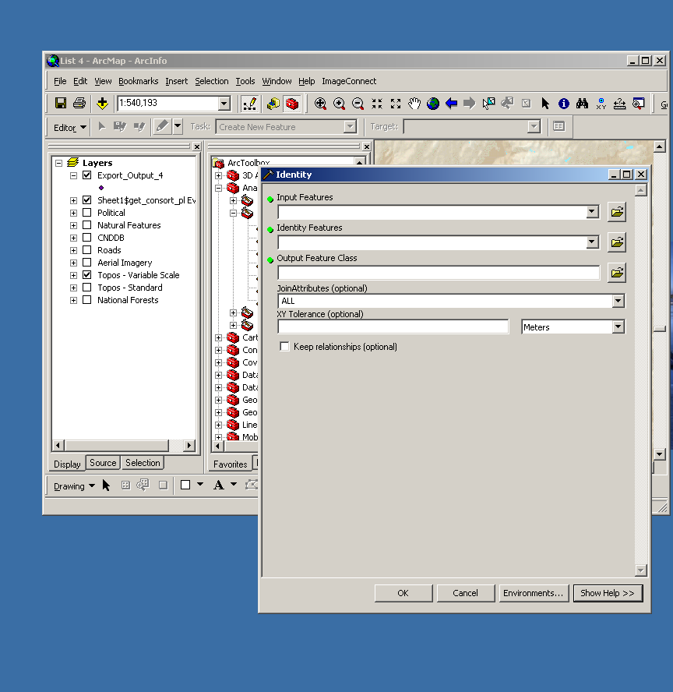

A new shapefile will appear in your ArcMap project. Right-click on this layer and select Open Attribute Table. When the attribute table opens, click the Options button at the bottom of it and select Export…

Specify where you would like to save a new table of collections with quad information. When asked if you would like to add the new table to the map, click No. You may close ArcMap at this point if you like.

Use Excel to open the table you created in the last step. This table will be in DBF format and will be difficult to read. Some columns will be nearly as wide as your screen. There are many restrictions on how a DBF table can be modified. Your table should be either be cleaned up and saved as an Excel workbook or certain columns of data should be copied and moved elsewhere before printing. You may copy and paste portions of the table into a template which has been created for printing. This template is saved at:
\\Molib01\CNDDB2006\Common\Documents\CNDDB_Training_Docs\List 3 & 4 plant sourcing

The directory that contains this template also contains an example of a table generated by the process you just followed, including explanations of the Consortium database fields.

